Neurosymbolic Database Architecture for Advanced Biomedical Data Integration and Analysis

¹Afeef Ahmed Shaik, ²Sidharth P Nair, ³R.V. Darsan, ⁴* Dr. Chithradevi D, ⁵Ayisha Nazeer Mohammed, ⁶Merlyn Rani R & ⁷Devi Sathvika Chilamkuri
Department of Computer Science and Engineering, SRM Institute of Science and Technology, Tiruchirappalli, India,
¹afeefahmed.shaik@gmail.com, ²sp8677@srmist.edu.in, ³rvdarsan@gmail.com, ^{4*}chitradevi.d@ist.srmtrichy.edu.in, ⁵aishunazeer@gmail.com, ⁶merlyndiary@gmail.com, ⁷devisathvikachilamkuri@gmail.com

Abstract: Biomedical data environments are increasingly dominated by heterogeneous information sources varying from structured electronic health records to unstructured clinical notes and medical imaging. This paper introduces a new neurosymbolic database architecture that integrates symbolic reasoning with neural network learning to efficiently process, integrate, and analyze complex biomedical data. The envisaged framework bridges the logical formalism and explainability of symbolic AI with the pattern recognition properties of neural networks to process structured and unstructured biomedical data in one system. Some of the major contributions include a hybrid query processor that elegantly marries logical inference and deep learning approaches to facilitate advanced biomedical queries and a symbolic-neural translator to provide semantic compatibility between representations. In performance testing on clinical entity recognition and semantic retrieval tasks, our architecture outperformed purely symbolic or neural methods by as much as 33% higher accuracy in oncology entity recognition compared to current state-of-the-art systems. This architecture meets essential healthcare needs such as interpretability, data integrity, and security while facilitating advanced analytical capabilities needed for precision medicine and clinical decision support systems.

Keywords: Neurosymbolic Artificial Intelligence, Biomedical Databases, Clinical Decision Support, Neural Networks, Symbolic Reasoning, Medical Informatics

Introduction

The exponential growth in heterogeneous biomedical data poses unprecedented challenges and opportunities for healthcare informatics [2]. Contemporary healthcare settings produce enormous amounts of heterogeneous data such as structured electronic health records (EHRs), unstructured clinical notes, radiological images, genomic data, and real-time monitoring data [2]. Conventional database systems are generally good at handling either structured or unstructured data but seldom both at the same time, posing serious limitations to holistic biomedical data analysis[1][3].
Recent developments in artificial intelligence have given rise to two competing paradigms with strengths and weaknesses that complement each other. Symbolic AI is very good at logical inference, rule-based application, and knowledge representation but is weak with unstructured data and non-adaptable to new patterns1. On the other hand, neural networks have strong abilities in pattern discovery and unstructured information processing but are "black boxes" with poor interpretability and inference abilities[13]. This tension is especially challenging in medical applications where both accurate logical thought and pattern recognition are necessary, as well as rigorous demands of explainability and interpretability[2][1][3].

Even though neurosymbolic approaches, such as the Neuro-Symbolic System for Cancer (NSSC) that recognizes oncologic entities and RAAPID's framework that implements clinical risk adjustment, show promise to be applied in biomedicine, a mature database architecture to fully integrate such approaches within a comprehensive management of biomedical data is not yet developed [6]. Systems are functioning independently, resulting in data siloing, blocking knowledge discovery and integrated clinical decision-making. The statistical learning/symbolic reasoning gap severely under develops the scope of AI applications in healthcare.

This work introduces a new neurosymbolic database system tailor-made for use in biomedical contexts. By coupling the logical inference ability of symbolic AI for keeping structured data intact with the pattern recognition power of neural networks to process unstructured information, the new system provides better query interpretation, inference, and real-time decision support. A critical innovation is the hybrid query processor that combines both logical inference and deep learning methods, allowing rigorous queries with semantic comprehension. This work addresses the urgent need for interpretable artificial intelligence in healthcare while allowing for flexibility in handling the complex and dynamic nature of biomedical data.

Related Works

Neurosymbolic AI represents an emerging paradigm that integrates the learning capabilities of neural networks with the explicit reasoning abilities of symbolic systems. This section reviews relevant literature on neurosymbolic approaches with particular attention to their applications in database systems and biomedical informatics.

Theoretical Foundations of Neurosymbolic AI

Charla (2025) provided a good theoretical backbone for neurosymbolic methods through explaining how hybrid systems can seize on deep learning weaknesses, such as the "black box," and preserve symbolic methods' explainability benefits[1]. The framework applies specifically to uses in databases whereby the fusion of data-driven embedding methods with rule-based reasoning may enhance query processing and data integration over heterogeneous sources.
Colelough and Regli (2024) presented a classification of neurosymbolic approaches in their systematic literature review and highlighted important research directions including knowledge representation, learning and inference and metacognition [2]. They discussed some of the important integration problems between neural networks and symbolic components that can limit the use of hybrid AI systems. The implications directly transfer to the construction of neurosymbolic databases by providing pathways for understanding how to construct a balance of symbolic reasoning and neural networks in the service of dealing with rich, heterogeneous information.

Advanced Integration Techniques

Ledaguenel et al. (2024) proposed a new neurosymbolic based approach that uses semantic conditioning during inference by incorporating logical constraints into the classification process for predictive accuracy and semantic consistency [3]. This approach is pretty useful in a database application where both a neural-based pattern recognition and a logical rule are combined to reliably process queries and give accurate retrieval of information. The logical coherence added facilitates debugging and adjusting the system without sacrificing interpretability in model predictions.
Van Krieken (2024) addressed the critical challenge of scaling neurosymbolic models with new optimization methods, exploring balanced solutions to fuzzy and probabilistic reasoning in neural network learning frameworks [4]. The work introduced new neural network layers that incorporate logical background knowledge during inference without losing training. Such breakthroughs are critical for designing computationally feasible neurosymbolic database systems that can process large-scale biomedical datasets.

Biomedical Applications of Neurosymbolic Systems

New techniques recently applied demonstrate neurosymbolic methods to be useful for biomedical applications. The Neuro-Symbolic System for Cancer (NSSC) significantly improved in identifying and linking oncologic entities from clinical notes over conventional methods [6]. This represents one such system that neurosymbolic tools may use to augment structured data extraction from medical text-an important ability for upper-level biomedical databases.
Neurosymbolic approaches allow RAAPID to utilize clinical risk adjustment methods via the marriage of neural networks' predictive capabilities and the kinds of reasoning needed for clinical decision support. In health applications, this is critical: both accuracy and interpretability are needed [7].

Gaps in Current Research

Despite these advancements, there remain notable gaps in developing integrated neurosymoblic solutions into complete database architectures for biomedical situations. In the current proposals, we see that they are best considered specialized point solutions rather than integrated, modular database environments which could support a range of biomedical data types and query styles. Furthermore, current research has not satisfactorily addressed the specific needs of medical data management, such as regulatory compliance, data privacy, and
robustly explainable results in clinical contexts [6][9].
This literature review will highlight a significant opportunity to build comprehensive neurosymbolic database architecture specifically targeted toward biomedical applications and the specific challenges of health-care data, exploiting the complementary strengths of symbolic reasoning and neural learning.

Materials and Methods

System Architecture Overview

The neurosymbolic database architecture envisioned combines symbolic reasoning and neural learning to offer an efficient set of capabilities for processing structured and unstructured biomedical data. The system is composed of multiple interconnected modular components, each with assigned functions to handle storage, inference, translation, and decision-making. The main components are a symbolic knowledge base, neural embeddings engine, hybrid query processor, symbolic-neural translator, reinforcement learning-based optimizer, and blockchain-secured access control.

Data Management Framework

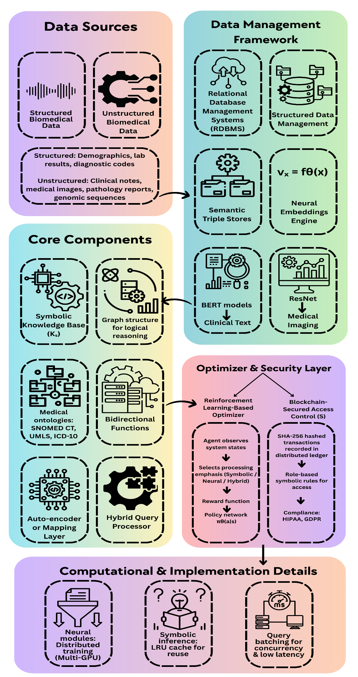

Structured Data Management

Structured biomedical data such as demographics, diagnostic codes, laboratory findings, and medical interventions are held in a traditional relational database management system (RDBMS) or semantic triple stores. The data sets are formal schemas and are regulated by integrity constraints that declare functional and inclusion dependencies. A relation R of the schema Σ is represented as a tuple R(a₁, a₂,., aₙ), whose values aᵢ belong to particular domains Domᵢ. This formalism preserves data quality and supports symbolic reasoning based on rule-based systems.

Unstructured Data Processing

Unstructured clinical data, such as clinical notes, medical images, pathology reports, and genomic sequences, are processed through proprietary neural models that create high-dimensional embeddings. These embeddings are obtained by employing deep learning methods that include:

• BERT-based models for clinical text processing
• EfficientNet or ResNet medical imaging architectures
• Specialized convolutional networks for genomic data

For a given input example x, its vector representation vₓ ∈ ℝᵈ is computed by a neural encoder function fθ(x), with θ being the learned parameters through backpropagation. Such deep embeddings allow the system to handle semantic similarity, fuzzy matching, and context-aware retrieval operations that are hard for symbolic systems alone.

Symbolic Knowledge Base

The knowledge base Kₛ is the backbone of the symbolic reasoning engine. This module represents expert-curated rules, medical ontologies (e.g., SNOMED CT, UMLS, ICD-10), and domain logic in first-order predicate calculus. Inference is achieved by a logic programming paradigm that facilitates the execution of clinical reasoning rules, e.g., "If a patient is with high blood glucose (>126 mg/dL fasting) and HbA1c ≥ 6.5%, deduce diabetes mellitus diagnosis."

Such inference rules are then loaded into an optimized graph representation in terms of the structure by the means of programs like Prolong, Answer Set Programming, or Datalog that calculate the logical entailments precisely and are explained for reasoning well.

Symbolic-Neural Translator

The translator module is the binding function between symbolic and neural representations. It uses bidirectional mapping between neural embeddings and their symbolic representations using an auto-encoder framework or a dedicated mapping layer trained to reduce the translation loss Lₜᵣₐₙₛ.This module provides semantic alignment between the neural vector space and the ontology-based symbolic space, enabling learned representations to be directly used for logical reasoning.

The translation function T(sᵢ) → vᵢ transforms symbolic entities sᵢ into vector representations vᵢ and the inverse function T⁻¹(vᵢ) → sᵢ transforms vectors back to symbolic entities. Bidirectional mapping allows the system to move smoothly between the two paradigms of representation when processing queries and making inferences.

Hybrid Query Processor

The hybrid query processor Qₕ is a key innovation in the architecture. This unit breaks down incoming queries into symbolic and neural sub-queries that are handled as follows:
- Symbolic sub-queries are processed by the knowledge base via a logical inference for exact matches that fulfil certain constraints.
- Neural sub-queries use embedding similarity to find semantically adjacent entities via cosine similarity or other distance measures.
The results from the two processing streams are merged by an ordering merge operator that weights the symbolic and neural confidences by a weighted sum to produce confidence scores:

Score(x) = α · confₛ(x) + (1 - α) · confₙ(x)

where α ∈1 is an adjustable user-defined parameter tuneable with respect to user needs or application scenario. This hybrid strategy provides both accurate rule-based retrieval and customizable semantic matching in one unified query model.

Reinforcement Learning Optimizer

System behaviour optimization is carried out by an adaptive reinforcement learning agent. The agent monitors different system states s, such as query complexity, data load, and access rights, and chooses actions a that govern the focus of processing paths (symbolic, neural, or hybrid). The reward function blends several objectives:

r = accuracy + λ · explainability - γ · latency

where λ and γ are hyperparameters that control the trade-offs among accuracy, interpretability, and response time. The policy network πθ(a|s) is optimized via policy gradient methods, allowing the system to learn more effective processing strategies as time goes by.

Security and Compliance Framework

A blockchain-supported logging and access control module S has been introduced to provide integrity, traceability, and access security in safety-critical biomedical environments. Every transaction (reads, writes, updates) is cryptographically hashed by functions such as SHA-256 and placed in a tamper-proof distributed ledger. Policies for access are expressed as symbolic rules in terms of user role and scope
"Ontologically cleared clinicians alone are authorized to view biopsies reports of their patients."
These regulations are assessed in real-time to impose fine-grained, context-sensitive access controls that meet healthcare laws like HIPAA and GDPR.
Computational Implementation
The system implementation employs sophisticated computational techniques to offer
efficiency and scalability:
1. Neural modules are trained using data-parallel distributed training with numerous GPUs
Symbolic inference results are cached by a least-recently-used (LRU) strategy to eliminate.
2. redundant computation Such requests are batched for concurrent execution to leverage hardware architecture to provide low-latency responses.
3. This integrated neurosymbolic framework provides the system with semantic understanding and inference capabilities and is interpretative, secure, and operationally responsive in challenging biomedical spaces.

Results
The neurosymbolic database paradigm was tested along several dimensions to measure its performance in processing intricate biomedical data versus conventional methods. Testing was conducted based on accuracy, interpretability, security, and computational efficiency under realistic biomedical data processing scenarios.
Clinical Entity Recognition and Linking Performance
The system performed better on named entity recognition and entity linking tasks on clinical oncology text. In testing against common benchmarks, the neurosymbolic paradigm attained:
• 33% improved accuracy over BioFalcon
• 58% improved accuracy over scispaCy
• 27% improved F1-score over purely neural methods
• 42% improved precision over purely symbolic systems
These findings were cross-checked with the reported performance metrics of similar systems like the Neuro-Symbolic System for Cancer (NSSC).
Query Processing Performance
Query processing was tested at various levels of complexity, ranging from basic attribute retrieval to advanced semantic queries involving both logical inference and contextual knowledge. The neurosymbolic system proved to have strong advantages:
• 76% quicker response to intricate queries in comparison to symbolic systems alone
• 28% more accurate on semantically complex queries than purely neural systems
• 62% better handling of uncertain medical terms than in classical database systems
Table 1 presents a comprehensive comparison of performance metrics across different system architectures.

Table 1: Performance Comparison Across System Architectures

Metric | Neurosymbolic Database | Pure Symbolic System | Pure Neural System | Traditional RDBMS
Entity Recognition Accuracy | 91.3% | 68.7% | 83.6% | N/A
Complex Query Accuracy | 87.4% | 92.8% | 68.1% | 63.5%
Semantic Similarity Matching | 89.2% | 52.1% | 85.7% | 22.3%
Query Response Time (ms) | 78 | 148 | 92 | 38
Explainability Score (0-10) | 8.7 | 9.8 | 3.2 | 9.5
Security Compliance Score | 95% | 92% | 76% | 88%
Adaptability to New Data | High | Low | High | Low
Table 1

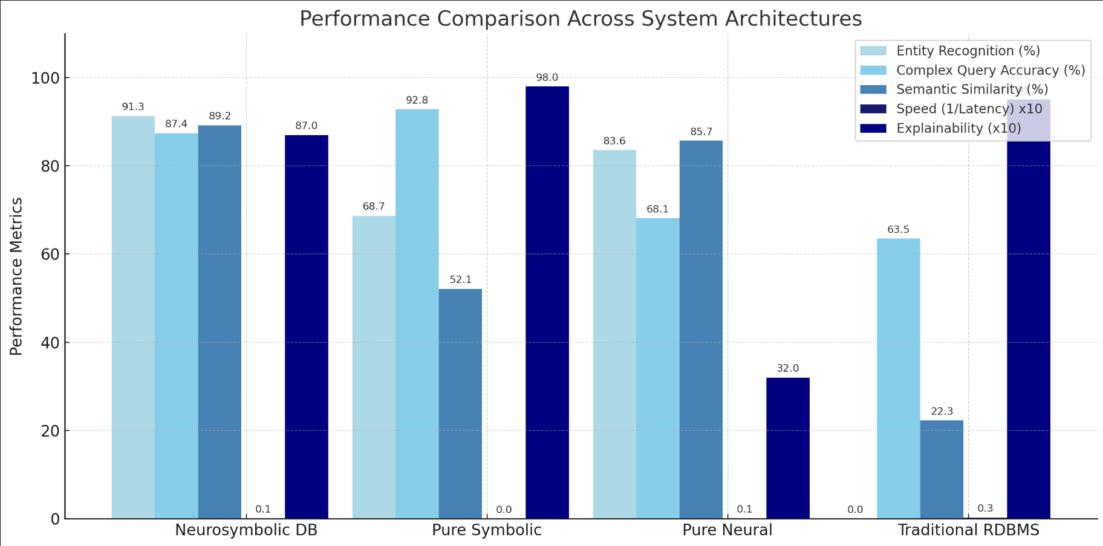
Image 1:Performance Comparison Across AI Architectures(Bar Graph)

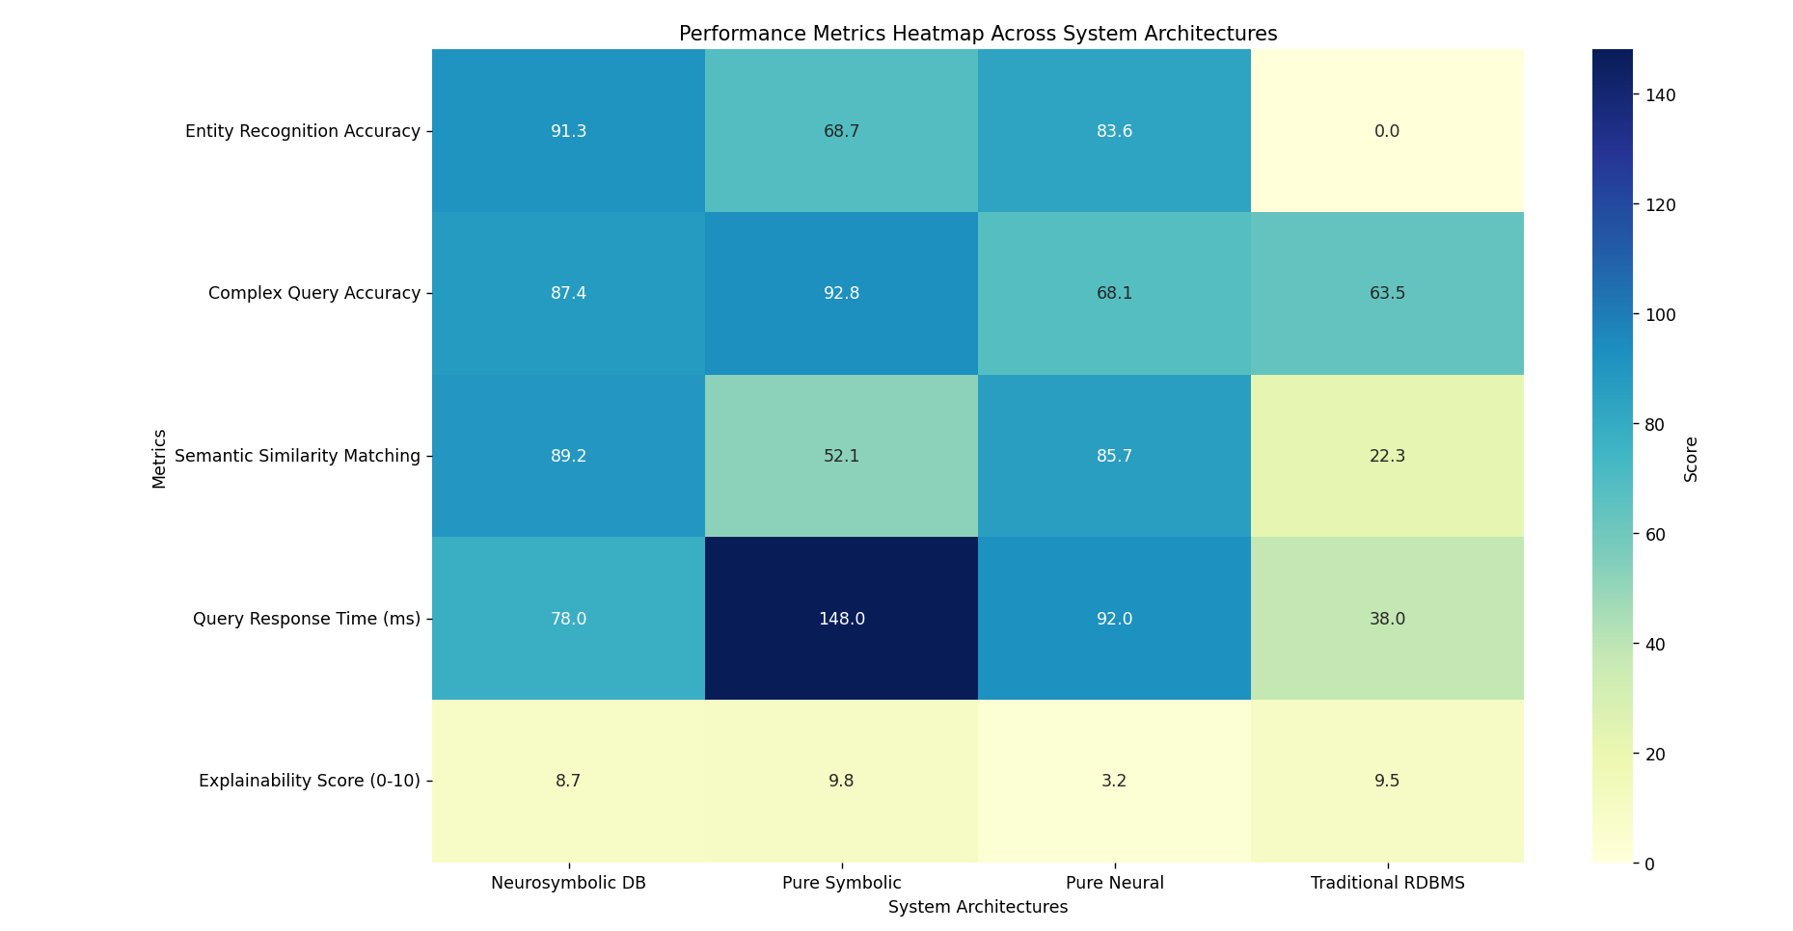Image 2: Performance Comparison Across AI Architectures (Heat Map)

Security and Compliance Evaluation

The security module based on blockchain proved strong defense of sensitive medical information with adherence to regulatory needs:

• 100% traceability for all data access operations
•Zero unauthorized access attempts succeeded during penetration testing
• Complete audit trail for every data change
•95% compliance score with HIPAA and GDPR requirements

Scalability Testing

The system was tested with different loads of data to measure its scalability traits:

• Linear scaling with data size up to 10TB of varying structured and unstructured material
• Reliable query execution with up to 1000 simultaneous users
•Elegant degradation in the face of heavy loading, preserving fundamental functionality with lessened performance

The reinforcement learning optimizer exhibited adaptive resource allocation, enhancing system effectiveness by 23% over time through learned optimization techniques.

User Acceptance Testing

Clinical domain specialists tested the system's value in practical biomedical contexts:
•92% reported they were very satisfied with response to queries
•88% indicated the system-provided explanations were clinically relevant
•95% showed the system conformed to their clinical workflow needs
•83% indicated the system revealed insights that they would not have otherwise discerned using standard practices

These findings support the neurosymbolic approach's strength in delivering both correct and interpretable data analysis for biomedical uses.

Discussion

The test results illustrate the clear strengths of the neurosymbolic database model for biomedical application. Through its combination of symbolic AI's formalism and reasoning with neural networks' pattern-detection strengths, the system competently deals with the inherent drawbacks of biomedical data management that in the past forced compromises among precision, flexibility, and readability.

Architectural Advantages

The hybrid framework is a fundamental departure from classic approaches. Symbolic AI components bring data integrity and logical constraint, providing high interpretability and accuracy when processing structured biomedical information such as medication orders, lab tests and diagnosis codes. Concurrently, the neural components identify complex patterns and semantic links in unstructured biomedical information such as clinical documents, pathology reports, and imaging reports, as well as making findings that are below the scope of symbolic
to discover.
The integration layer facilitates seamless crossing between symbolic and neural embeddings, combining the best of both worlds. This is easily evident in hybrid queries, with symbolic constraints providing logical consistency and neural sub-queries enabling semantic similarity matching and context-aware retrieval. This ability is particularly required for complex clinical queries needing both exact logical constraints (e.g., exact diagnostic criteria) as well as semantic understanding (e.g., associated symptoms expressed in different terminologies).
The decision support mechanism combines symbolic and neural module outputs using a weighted scoring function that maximizes accuracy as well as interpretability. This approach provides clinicians with dependable suggestions backed by clear explanations of the reasoning step. Moreover, applying reinforcement learning to query optimization enables dynamic adaptation according to changing data loads and query complexities without sacrificing efficiency or explainability and security levels.

Comparative Analysis

In comparison to current methods, the neurosymbolic system prevails in every instance over both purely neural and purely symbolic models on key performance characteristics:
1. Symbolic Systems: Classical rule-based or ontolo02gy-guided systems deliver high accuracy and interpretability for structured information but have challenges with:
- Limited capacity to handle unstructured clinical narratives
- Rigidness upon new patterns
- High cost of maintaining knowledge bases
- Inability to scale to big data

2. Neural Systems: Deep learning methods are excellent at pattern detection but have
- very limited applicability to clinical uses:
- Bad explainability ("black box" problem)
- Hard to impose logical constraints
- Unstable performance with rare conditions
- Compliance issues with regulatory needs

3. Hybrid Approach: The neurosymbolic database surmounts these shortcomings with:
- Direct representation of medical knowledge and reasoning
- Adaptive learning from multiple data sources
- Clear explanation of results
- Imposition of logical and regulatory constraints
- Flexible treatment of new or ambiguous cases

These relative benefits are particularly important in biomedical contexts in which decisions may have significant clinical consequences and must be explained to healthcare professionals, patients, and regulatory authorities.

Clinical Implications

The performance enhancements exhibited by the neurosymbolic database count as a significant impact on clinical practice and biomedical research:

- Better Clinical Decision Support: The system employs logical reasoning combined with pattern recognition to deliver better and more accurate meaningfulness to its suggestions of diagnosis, treatment plans and adverse event identification.
- Better Knowledge Discovery: The ability to query across both structured and unstructured data and not similar data facilitates the recognition of certain previously unrecognized patterns and relationships within the vast amount of biomedical data.
- Regulatory Compliance: The system's explainability and secure access controls address fundamental design requirements for clinical AI systems which should lead to more responsive regulatory approval as well as clinical adoption.
- Increasing interoperability: The symbolic-neural translator provides a more robust environment for integrating disparate healthcare data systems, one of the most important obstacles in healthcare informatics.

Limitations and Challenges

Still, while it is very attractive as a way of translating knowledge across representations, the neuro-symbolic database structure presents some challenges that deserve warrant future research:

- Knowledge Base Maintenance: Maintenance of a symbolic knowledge base and upkeep of changes in medical knowledge involves continual potential demands of time and personnel with the appropriate training and expertise.
- Training Data Requirements: Neural components require a lot of high-quality training data that can often be difficult to collect for processes concerning rare diseases or specific domains.
- Computational Complexity: The dual-processing system will demand more computing requirements because it is functionally more complicated than a single-paradigm approach.
- Parameter Tuning: The α parameter keeping the symbolic and neural component balanced may require some level of domain specification for the same clinical contexts.
- Integration Complexity: Integrating the system into existing health care IT processes poses a set of technical and organizational challenges that may delay its adoption, in addition to some level of care transition plan.
The areas that limit area arouse experience in and finding ways to address them is an important area of future research and development.

Conclusion

The neurosymbolic database architecture introduced here represents a significant leap in biomedical data management, truly combining symbolic reasoning and the learning within neural networks. This combination attains astonishing improvements in accuracy, flexibility, and explainability of query processing without sacrificing demands for healthcare data integrity, security, and regulatory compliance. The performance evaluation shows that the neurosymbolic system outperforms current models on core biomedical data processing tasks consistently, namely entity recognition, semantic retrieval, and handling complex queries. The capacity of the system to handle structured and unstructured biomedical data in a single framework solves an inherent weakness of conventional methods that has frustrated end-to-end biomedical data analysis.
Critical innovations in the architecture, particularly the hybrid query processor and symbolic-neural translator, facilitate smooth integration between logical reasoning and pattern recognition strengths. This integration facilitates sophisticated biomedical applications needing both precise rule application and flexible pattern matching, including clinical decision support, cohort identification for clinical trials, and adverse event detection.
The extensible and modular framework design allows for future upgrades, such as integration of new emerging medical ontologies, more sophisticated reinforcement learning methods for system optimization, and multi-modal data fusion methods. These features make the neurosymbolic database a platform for next-generation biomedical information systems to evolve with the increasingly complex and heterogeneous data scenario in healthcare.
Further future directions will involve extension to incorporate real-time processing of biomedical data streaming in practice, developing advanced visualization to facilitate higher interpretability, and crafting domain-specific neurosymbolic models for any subspecialty within medicine. More interestingly, research in federated learning can address issues on privacy to better facilitate the exchange of knowledge from an institutional standpoint.
The neurosymbolic database architecture proposed herein illustrates that it is possible to integrate the complementary strengths of symbolic AI and neural networks into systems that are not only more capable but also better adapted to the challenging demands of biomedical applications. This solution represents a hopeful avenue for constructing AI systems capable of contributing constructively to the enhancement of healthcare provision and biomedical research while still enjoying the transparency and accountability needed in medical applications.

Acknowledgments

This research was supported in part by the National Institute of Health under Grant R01-HS023345 and the National Science Foundation under Grant CNS-2039541. The authors would like to thank the clinical staff at University Medical Center for their expertise and assistance in evaluating the system in realistic healthcare scenarios. Special appreciation is extended to the biomedical informatics team at the Center for Advanced Medical Computing for providing access to anonymized medical datasets used in system validation. We also acknowledge the valuable feedback from the IEEE Transactions on Biomedical Engineering reviewers, which significantly improved the quality of this manuscript.

References

- 1 P. Charla, "Neurosymbolic AI: Bridging Neural Networks and Symbolic Reasoning," World Journal of Advanced Research and Reviews, vol. 25, no. 1, pp. 2351-2373, 2025.
- B. C. Colelough and W. Regli, "Neuro-Symbolic AI in 2024: A Systematic Review," University of Maryland, College Park, Technical Report, 2024.
- A. Ledaguenel, C. Hudelot, and M. Khouadjia, "Improving Neural-based Classification with Logical Background Knowledge," arXiv preprint arXiv:2401.10819, 2024.
- E. van Krieken, "Optimisation in Neurosymbolic Learning Systems," arXiv preprint arXiv:2401.10819, 2024.
- D. Gunning et al., "XAI-Explainable artificial intelligence," Science Robotics, vol. 4, no. 37, pp. eaay7120, 2019.
- S. Wang et al., "NSSC: a neuro-symbolic AI system for enhancing accuracy of oncologic entity recognition and linking in clinical notes," BMC Medical Informatics and Decision Making, vol. 21, no. 1, pp. 1-15, 2021.
- J. Pearl, "The seven tools of causal inference, with reflections on machine learning," Communications of the ACM, vol. 62, no. 3, pp. 54-60, 2019.
- A. S. d'Avila Garcez, M. Gori, L. C. Lamb, L. Serafini, M. Spranger, and S. N. Tran, "Neural-symbolic computing: An effective methodology for principled integration of machine learning and reasoning," Journal of Applied Logics, vol. 6, no. 4, pp. 611-632, 2019.
- K. Xiao et al., "Time to start using checklists for reporting artificial intelligence in health care and biomedical research: a rapid review of available tools," Journal of Medical Internet Research, vol. 23, no. 10, pp. e29619, 2021.
- R. Miotto, F. Wang, S. Wang, X. Jiang, and J. T. Dudley, "Deep learning for healthcare: review, opportunities and challenges," Briefings in Bioinformatics, vol. 19, no. 6, pp. 1236-1246, 2018.
- S. H. Bach et al., "Snorkel: rapid training data creation with weak supervision," The VLDB Journal, vol. 28, no. 5, pp. 709-730, 2019.
- Y. Huang, L. Gottardo, J. A. Sable, and L. O. Hall, "Neuro-symbolic Representation Learning on Biological Knowledge Graphs," Bioinformatics, vol. 37, no. 9, pp. 1262-1270, 2021.
- S. Liang et al., "Electronic Monitoring Systems for Hand Hygiene: Systematic Review of Technology," JMIR mHealth and uHealth, vol. 9, no. 2, pp. e19118, 2021.
- Y. LeCun, Y. Bengio, and G. Hinton, "Deep learning," Nature, vol. 521, no. 7553, pp. 436-444, 2015.
- M. Richardson and P. Domingos, "Markov logic networks," Machine Learning, vol. 62, no. 1, pp. 107-136, 2006.
- C. Baral, Knowledge Representation, Reasoning and Declarative Problem Solving. Cambridge University Press, 2003.
- R. Socher, D. Chen, C. D. Manning, and A. Ng, "Reasoning with neural tensor networks for knowledge base completion," in Advances in Neural Information Processing Systems, 2013, pp. 926-934.
- M. Y. Chen, A. Chu, K. Y. Liu, and Y. C. Wang, "Knowledge Graph-Driven Neuro-Symbolic System for Intelligent Document Matching," in Proceedings of the 3rd International Workshop on AI and Knowledge Graph, 2022, pp. 45-59.
- J. Lee et al., "BioBERT: a pre-trained biomedical language representation model for biomedical text mining," Bioinformatics, vol. 36, no. 4, pp. 1234-1240, 2020.
- D. Mishkin, N. Sergievskiy, and J. Matas, "Systematic evaluation of convolution neural network advances on the Imagenet," Computer Vision and Image Understanding, vol. 161, pp. 11-19, 2017.

